**Name: Shruti Deepak Dhumne PRN: 0220200161 (Computer Engineering)**

**Roll No: 227 Seat no: S204156 Date: 1/July/2021**

**Graded Activity (Assignment Set 1)**

* **SQL Queries**

Create Table Book5(Bookid Number Constraint book5_pk PRIMARY KEY ,

title Varchar2(40) not null,

author Varchar2(40) not null,

totalpages Number,

price Number not null,

publication Varchar2(40),

dateofpublication Date not null,

sales Number,

availablebook Number not null,

rating Number )

insert into Book5 values (101, 'Let us c', 'Yashavant Kanetkar', 320,800,'BPB','11-20-2002',205,100,3);

insert into Book5 values (102, 'DataStructure though C', 'Yashavant Kanetkar', 590,1200,'BPB','11-10-2019',205,100,4);

insert into Book5 values (103, 'GAAP', 'Steven Bragg', 400,1186,'Wiley publication','12-10-2018',400,10,2);

insert into Book5 values (104, 'Accounting Best Practices', 'Steven Bragg', 1010,1006,'Tech max','08-10-2016',110,80,3);

insert into Book5 values (105, '2 States', 'Chetan Bhagat', 1230,1200,'Rupa','08-08-2009',185,120,4);

select * from Book5;

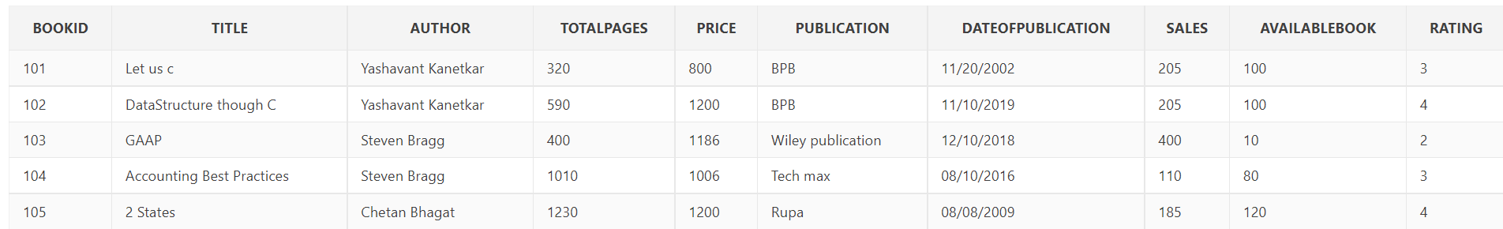

1. select *from Book5 where price <(select price from Book5 where bookid=102)

(23 is not there in my table so I had use id as 102)

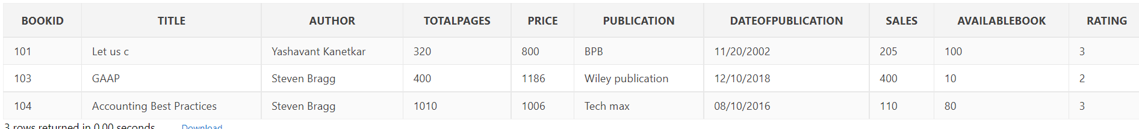

2. select * from book5 where rating > (select rating from book5 where publication = 'Wiley publication');

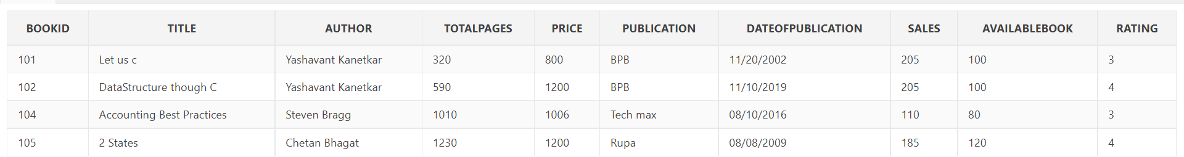

3.Select author,min(rating) From Book5 Group By(author)

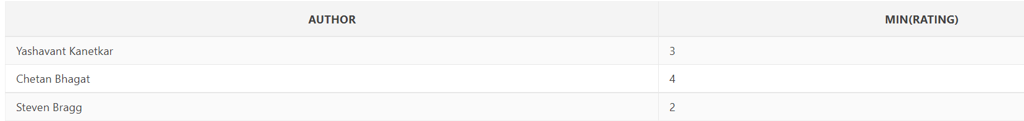

4. select * from book5 order by rating desc fetch first 2 rows only



* **MangoDB Queries**

> db.createCollection("Book5")

> db.Book5.insert({bookid:1 , title:"Physics", authorname:"R.D.sharma" , Noofpages:850, price:250,Publication:"Nirali", datoofpublication:10-08-2012,noofsale:1500,booksavailable:10000,rating:5})

WriteResult({ "nInserted" : 1 })

> db.Book5.insert({bookid:2 , title:"Psychology", authorname:"S.D. Shekhsphere" , Noofpages:500, price:350,Publication:"orion", datoofpublication:10-05-1990,noofsale:5000,booksavailable:100000,rating:5})

WriteResult({ "nInserted" : 1 })

> db.Book5.insert({bookid:3 , title:"Emma", authorname:"Austen" , Noofpages:800, price:750,Publication:"Modern library", datoofpublication:27-06-1990,noofsale:2575,booksavailable:57800,rating:3})

WriteResult({ "nInserted" : 1 })

> db.Book5.insert({bookid:4 , title:"Macbeth", authorname:"Shekhsphere" , Noofpages:550, price:899,Publication:"Dover", datoofpublication:27-02-1985,noofsale:5372,booksavailable:9280,rating:4})

WriteResult({ "nInserted" : 1 })

> db.Book5.insert({bookid:5 , title:"Oliver Twists", authorname:"dikens" , Noofpages:650, price:750,Publication:"Penguin Classics", datoofpublication:29-03-1999,noofsale:5572,booksavailable:8800,rating:2})

WriteResult({ "nInserted" : 1 })

1. db.Book.find({price:{$lt: "price":250 }})
2. NA
3. db.Book.find({bookid:{$lt:{$match:{bookid:1}}}})
4. db.Book.find({bookid:{$max:rating}.limit(2)} )